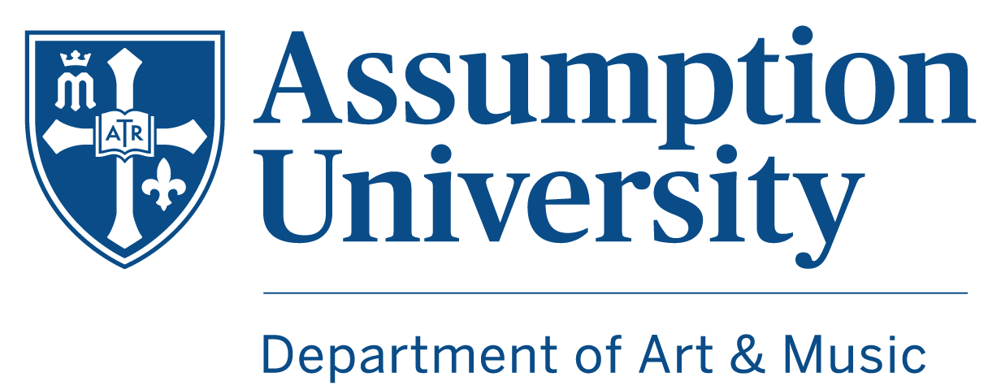
Vocal Scholars Audition Information
2023 – 2024
For students entering in Fall 2023.
Preliminary video due January 9 for scholarship priority. Rolling offers after this date are note guaranteed.

Scholarship Award: $2,500-$5,000 per year, renewable each year for four years.
Scholarship Expectations: Full participation as a leader in Assumption Chorale and as a singer in the VOCE chamber choir by audition for the duration of award. Participation in voice class during Year 1. Participation in private voice lessons at least one semester per year in years 2, 3, and 4. (A portion of this scholarship is intended to help offset the cost of one semester of private lessons each year.) Participation in special and culminating events as a singer (admissions days, recitals, etc.). When possible, participation in international choral tours. Re-evaluation of commitment at the end of second year. Full commitment to the ongoing expectations of the Vocal Scholars program as representatives of Assumption University in our community.
Audition Timeline
- Fill out the online application form and submit all video audition materials by Friday, January 6, 2023.
- Apply to Assumption University alongside the scholarship application.
- Receive notification of invitation to interview by Monday, January 9, 2023.
- Participate in an in-person interview, if invited, on January 26 or 27, 2023.
- Receive notification of offer by the middle of February.
The Application
- Be prepared to fill out all information in your online application form when submitting.
- Carefully follow the video guidelines listed below to accompany your application.
- After submitting your audition information online, please direct any questions or concerns to admissions.
Guidelines on Repertoire Selection for Video Audition
- We are looking to hear two contrasting pieces of varied musical styles. Your teachers may be your best resource in selecting these pieces, but please be in touch if you have questions.
- Both pieces should be chosen to display healthy vocal technique regardless of genre.
  - Examples: Selection from the 24 Italian Songs and Aria’s anthology, hymn tunes such as Amazing Grace, a traditional folk song or Americana tune, jazz standards, or classic musical theater selections such as Rodgers and Hammerstein pieces.
- You are encouraged to memorize the pieces, although it is not required.
- We are not necessarily looking for the most highly polished and technically perfect singer. We are looking for singers with strong natural ability that we believe can grow and develop over four years here.
- Remember that we want to see you succeed and find a home on our campus!
Guidelines on Recording
- You should plan to send in a recording that best represents you and your musical ability. Please be in touch with us if you experience any significant technical difficulties. We would like to help you succeed.
- Please plan to submit your audition as one (1) video file that includes both pieces.
- Before you sing, please introduce yourself by stating where you are from, your background in music and/or theater, why you are interested in Assumption, and what you will be singing. This can be under two minutes.
- Video should be submitted as a link to an uploaded file. If this is Google Drive or YouTube, please make sure the video is shared to allow for viewing and not a closed video.
- Please plan to use the audio that is recorded with the video and do not lip sync to audio that you record and edit separately.
- Utilizing an accompanist is ideal, but we understand that you may need to sing a cappella and/or with a digital piano pre-recording. Please make sure that we can hear this track, though we understand the balance may not be perfect. Hearing your voice will be the most important part of this.
- Please present this audition in a quiet and intentional setting where you can stand and sing comfortably without distraction.
- Again, we want to see a recording that best represents you and your musical ability. Background noise, other people in the video, and distracting environments can take away from this. We want to see you do your best work, so try and set up your environment for this!

The In-Person Interview
- If invited, a 15-minute interview will be scheduled for afternoon/evening of January 26 or 27. Limited accommodations can be made if this date cannot work or if travel to MA is not possible.
- Please be prepared to sing both of your selections from your video. We may only ask for one of them. Please also be prepared to sight-read from a simple score. The sight-reading itself will not have weight on the success of your audition.
- Please be prepared to receive coaching from the faculty. We will have you go through a series of warm-ups and sightread a short selection. We are looking to see how you respond to feedback and instruction.
- This interview will be a space for us to hear from you, answer questions, and learn a bit more about your interest in Assumption University. Please come prepared with any questions you have about the Vocal Scholars program, music degree, or Assumption in general.

And remember, we want to see you succeed! Reach out for our support if you need help preparing.
We would rather see you communicate with us and try then not submit anything at all!

Program Contacts

Mr. Brad Dumont
Director of Choral Activities
bt.dumont@assumption.edu

Ms. Margaret M. Tartaglia
Professor of Voice
m.tartaglia@assumption.ed
Dr. Peter Clemente
Professor of Music, Department Chair
pclement@assumption.edu

For more information, please reach out to any of the program contacts. We will be thrilled to discuss your visit to Assumption and hear your voice!

The audition committee will consist of the music faculty listed here.

